
Nanyang Technological University
Academic Year 2024/2025 Semester 2
SC4001: Neural Network & Deep Learning

Group Assignment Report

Submitted by:
Name: | Matriculation Number:
Mak Chee Cheng | U2210533J
Ruvenn Siow Hao Ming | U2122434F
Teo Hong Guan Brian | U2223970G

Date of Submission: 9/4/2025

Table of Contents
Introduction 3
Review Of Existing Techniques 4
Description of Methods Used 5
1. Pretraining with CelebA Dataset 5
2. EfficientNetB5 5
3. RNN with Multi-Scale Dilated Convolutions 5
Experiments & Results 6
1. Pretraining with CelebA Dataset 6
2. EfficientNetB5 7
3. RNN with Multi-Scale Dilated Convolutions (grey-scale) 9
Discussion 12
References 13

Introduction
Automatic gender classification is a fundamental element of numerous applications, such as security systems, targeted marketing campaigns, human-computer interaction, and population studies. Facial image-based gender identification is a difficult task as it relies on various factors like lighting, pose, occlusion, and inherent facial features.

The aim of this project is to develop a deep learning model for gender classification from facial images. To achieve this, a convolutional neural network (CNN) or a Transformer-based architecture can be implemented. We will study and explore improvements to existing models, including increasing the network depth, parameter tuning, and introducing new techniques such as deformable convolutions, dilated convolutions, or visual prompt tuning.

In automatic gender classification, early methods were primarily founded on hand-crafted features from facial images, such as geometric measurements and texture descriptors. Conventional methods tended to be sensitive to lighting changes, pose, and facial expressions, and their performance was not stable. The advent of deep learning, particularly Convolutional Neural Networks (CNNs), ushered in a revolutionary shift by enabling models to learn hierarchical feature representations from raw pixel data. This modification has resulted in dramatic improvements in classification accuracy and robustness. [1]

Review Of Existing Techniques
​One notable example is the work by Levi and Hassncer, who proposed a CNN architecture tailored for age and gender classification tasks. Their research demonstrated that with limited training data, deep learning techniques were able to outperform traditional methods by detecting subtle facial features with high accuracy. They achieved this through a relatively simple CNN architecture, which was tested and trained on the Adience dataset—a collection of raw face images with varied poses and lighting. Their results indicated a dramatic performance increase, demonstrating the potential of CNNs for this task. [2] Liu et al. introduced a novel deep learning framework that cascades into two CNNs, named LNet and ANet, for face attribute prediction. LNet is pre-trained on general object classes for face localization, while ANet is pre-trained on large-scale face identities for attribute prediction. Through this cascading approach, the model can handle difficult face variations more effectively. The framework not only outperformed current state-of-the-art methods but also showed that high-level hidden neurons could automatically discover semantic concepts about facial attributes. This paper highlighted the necessity of strategic pre-training and the ability of CNNs in capturing intricate facial features for accurate gender classification. [3]

EfficientNetB5 is a cutting-edge deep learning model designed for high performance and computational efficiency. It is part of the EfficientNet family, which revolutionized CNN architecture by introducing a compound scaling method. This approach optimally balances the depth, width, and resolution of the network, allowing for better performance while minimizing computational costs. Unlike traditional models, EfficientNet scales all dimensions of the network uniformly, enabling it to achieve significantly higher accuracy with fewer parameters and less computational overhead. The model has been pre-trained on the ImageNet dataset, allowing it to effectively learn general image features. Due to its powerful feature extraction capabilities, EfficientNetB5 is highly versatile and well-suited for a wide range of image classification tasks. Its ability to capture intricate patterns and details from images makes it particularly effective for tasks such as gender classification. [4]

Integrating dilated convolutions into ResNet architectures has enhanced feature extraction by expanding the receptive field without increasing model complexity. For instance, Yu et al. introduced Dilated Residual Networks (DRNs),[5] which outperform their non-dilated counterparts in image classification tasks. Similarly, Zhang proposed a modified ResNet101 model incorporating dense dilated convolutions, achieving improved accuracy in medical liver tumor classification.[6] These advancements underscore the effectiveness of combining dilated convolutions with ResNet architectures for enhanced image classification performance.

Description of Methods Used

Pretraining with CelebA Dataset
Utilizing Levi and Hassncer’s CNN model as the baseline model, we pretrained it with the CelebA dataset before training it on the Adience dataset. A new instance of the baseline model is then created and trained with just the Adience dataset. Following that, the CelebA pretrained model’s accuracy is compared against the baseline model which had only been trained on the Adience dataset.

EfficientNetB5
We used the pre-trained EfficientNetB5 model, originally trained on the ImageNet dataset for image classification tasks and fine-tuned it for gender classification using the Adience dataset. The pre-trained layers were frozen to retain the knowledge learned from ImageNet, and custom layers were added on top to suit the gender classification task. The model was then trained on the Adience dataset, leveraging the powerful feature extraction capabilities learned from ImageNet to adapt to the gender classification task.

RNN with Multi-Scale Dilated Convolutions
We developed a deep learning model that integrates a pre-trained ResNet-18 architecture with custom multi-scale dilated convolutional blocks to enhance feature extraction. Specifically, we replaced the deeper ResNet layers with two bespoke Multi-Scale Dilated Convolution Blocks, each comprising parallel convolutional layers with dilation rates of 1, 2, 4, and 8. The outputs from these dilated convolutions were then concatenated, batch-normalized, and activated using ReLU functions. This design aims to expand the receptive field and capture multi-scale contextual information without significantly increasing computational complexity.

Experiments & Results

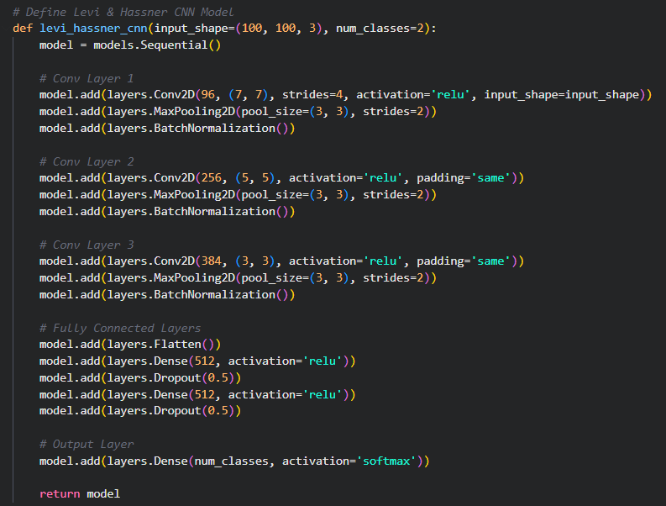
Pretraining with CelebA Dataset
Figure 1: Levi & Hassner CNN
Figure 1 shows how the Levi and Hassncer CNN model had been created with 3 convolutional layers followed by fully connected layers and finally the output layer. The images in both the CelebA and Adience datasets are first pre-processed to have the standard size of 100 x 100 pixels. Then, one instance of the model gets trained with the CelebA and Adience dataset while another instance is only trained on the Adience dataset. Lastly, the accuracies of these 2 models are compared when testing on Adience test split as shown in figure 2 below with the CelebA pretrained model performing slightly better than the baseline model in terms of accuracy.
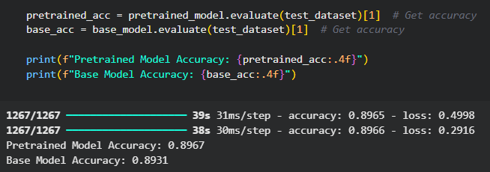
Figure 2: Comparison of Model Accuracies

EfficientNetB5
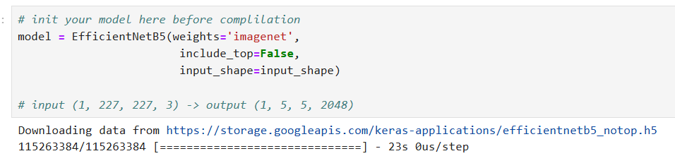Figure 3: EfficentNetB5 imported pre-trained weights from ImageNet
Figure 3 illustrates the architecture of the gender classification model using the EfficientNetB5 as the base network. Initially, the model is imported with pre-trained weights from the ImageNet dataset, using the following code. This model architecture excludes the top classification layer, which allows us to add custom layers tailored to the gender classification task.

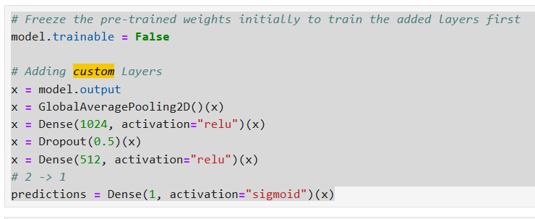Figure 4: Custom layer added to EfficientNetB5 for gender classification
Next, to tailor the model to our gender classification task, custom layers were added on top of the EfficientNetB5 backbone as shown in figure 4.
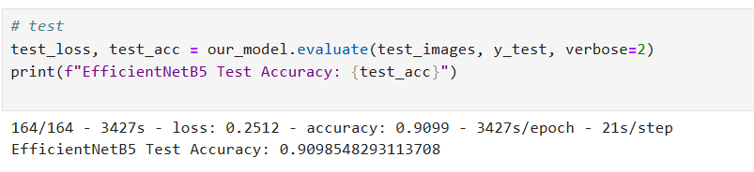Figure 5: Accuracy of finetuned EfficientNetB5
The result of our fine-tuning process, as part of the transfer learning approach using EfficientNetB5, achieved an impressive test accuracy of 0.9099. This indicates that the model performed well on the gender classification task, demonstrating the effectiveness of leveraging pre-trained weights from the ImageNet dataset for this task.

RNN with Multi-Scale Dilated Convolutions (grey-scale)
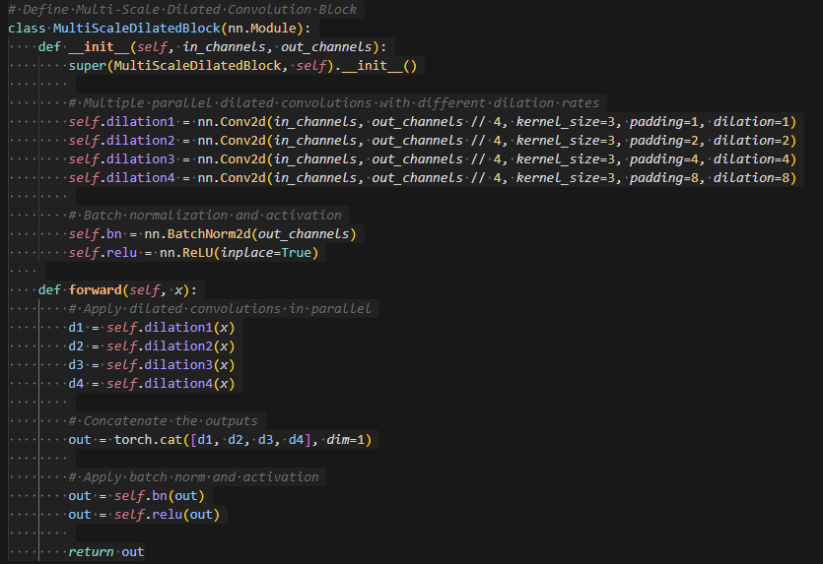
Figure 6: MultiScaleDilatedBlock
In Figure 6, it shows the implementation of the MultiScaleDilatedBlock class. It is a custom convolution block by using parallel dilated convolutions with varying dilation rates (1, 2, 4, and 8). The outputs of these layers are concatenated along the channel dimension. Finally, batch normalization and a ReLU activation function are applied to stabilize training and introduce non-linearity.
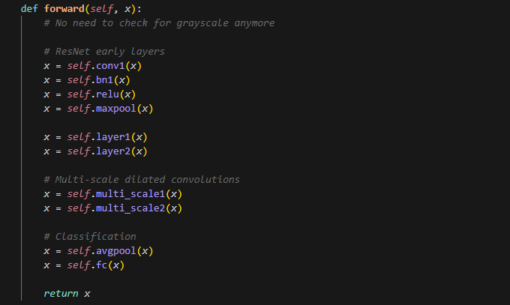
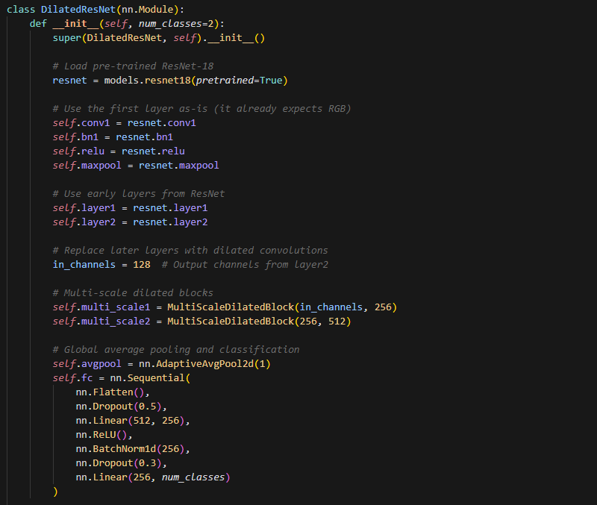
Figure 7: DilatedResnet Model
Figure 8: DilatedResnet Model (Continuation)
Figure 7 and 8 shows how the DilatedResnet Model is created. It starts with using the pretrained ResNet-18’s initial layers to extract low-level features. The later stages are replaced with custom MultiScaleDilatedBlock modules. A global average pooling layer condenses the spatial information, followed by a fully connected classification head with dropout and batch normalization for regularization.

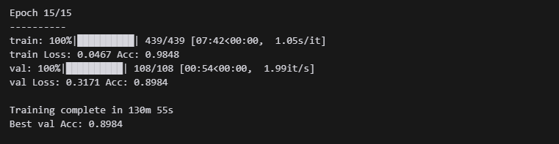Figure 9: DilatedResnet Accuracy
Figure 9 shows the accuracy of the model on the validation set.

Discussion
This project investigated various deep learning solutions to the task of automatic gender classification, highlighting the merits and drawbacks of each. To begin with, pretraining the baseline CNN model using the CelebA dataset resulted in a modest yet significant improvement over training using only the Adience dataset. This finding supports the hypothesis that a larger dataset can enhance generalization capacity. Second, the EfficientNetB5 model that was fine-tuned for gender classification achieved the best test accuracy (90.99%), which reflects the success of transfer learning from large-scale image datasets like ImageNet.

The DilatedResNet model introduced multi-scale dilated convolutions to capture diverse spatial features, which proved promising despite not outperforming EfficientNet. The use of grayscale input helped reduce computational load, though converting it back to 3-channel input (for ResNet compatibility) may have limited its potential gains. Overall, the results highlight that combining strong pretrained backbones with architectural innovations—like multi-scale dilation—can yield effective gender classification systems, even on challenging datasets like Adience.

For future works, we suggest incorporating deformable convolutions or attention-based mechanisms (such as visual prompt tuning or Vision Transformers) which could potentially improve the flexibility of models and focus on critical facial regions. Additionally, experimenting with facial landmark alignment, data augmentation strategies, or ensembling different models may further boost performance. More in-depth research or testing on dilation rates, channel sizes, and grayscale vs. colour input could also yield deeper insights into architectural choices and their impact on generalization.

References
[1] K. Khan, M. Attique, I. Syed, and A. Gul, “Automatic Gender Classification through Face Segmentation,” Symmetry, vol. 11, no. 6, Art. no. 6, Jun. 2019, doi: 10.3390/sym11060770.
[2] G. Levi and T. Hassncer, “Age and gender classification using convolutional neural networks,” in 2015 IEEE Conference on Computer Vision and Pattern Recognition Workshops (CVPRW), Boston, MA, USA: IEEE, Jun. 2015, pp. 34–42. doi: 10.1109/CVPRW.2015.7301352.
[3] Z. Liu, P. Luo, X. Wang, and X. Tang, “Deep Learning Face Attributes in the Wild,” in Proceedings of the 2015 IEEE International Conference on Computer Vision (ICCV), in ICCV ’15. USA: IEEE Computer Society, Dec. 2015, pp. 3730–3738. doi: 10.1109/ICCV.2015.425.
[4] Tan, M., & Le, Q., V. (2019, May 28). EfficientNet: Rethinking model scaling for convolutional neural networks. arXiv.org. https://arxiv.org/abs/1905.11946
[5] F. Yu, V. Koltun, and T. Funkhouser, "Dilated Residual Networks," presented at the 30th IEEE Conference on Computer Vision and Pattern Recognition (CVPR), Honolulu, HI, USA, Jul. 2017, pp. 636–644. doi: 10.1109/CVPR.2017.75.
[6] Q. Zhang, "A Novel ResNet101 Model Based on Dense Dilated Convolution for Image Classification," SN Applied Sciences, vol. 4, no. 1, Dec. 2021, Art. no. 9. doi: 10.1007/s42452-021-04897-7.

